Supplementary Material:

Cerebral blood flow rates in recent great apes are greater than in Australopithecus species that had equal or larger brains

Roger S. Seymour, Vanya Bosiocic, Edward P. Snelling, Prince C. Chikezie, Qiaohui Hu, Thomas J. Nelson, Bernhard Zipfel, and Case V. Miller
Proceedings of the Royal Society B: Biological Sciences DOI: 10.1098/rspb.2019.2208

Computational approaches to evaluate blood flow rate from foramen size
This study uses a new, empirical approach to calculate internal carotid artery (ICA) blood flow rate from the radius of the carotid canal. So it is worthwhile to compare this new “empirical equation” with the previous one based on the Poiseuille-derived “shear stress equation”. The techniques used to measure the canal size (CT scans, microphotographs and impression casting) are comparable, and a sensitivity analysis of the shear stress equation reveals reasonable accuracy (Qiaohui Hu et al. 2019 in press). However, there are two assumptions that weaken the foramen technique and use of the shear stress equation: the arterial wall thickness-to-lumen radius ratio is assumed a constant (Assumption 1) and the scaling of wall shear stress is calculated from the body mass of the animal (Assumption 2).
Assumption 1: The arterial wall thickness-to-lumen radius ratio being a constant is reasonable. Larger arteries develop thicker walls because average wall cross-sectional stress is normalized according to the Principle of Laplace that requires the wall thickness to increase in proportion to blood pressure and the radius of the vessel [1, 2]. Central mean arterial blood pressure is practically independent of body mass in mammals the size of primates; there is no significant difference in mean arterial blood pressure in mammals the size of a 4.24 kg Macaca fascicularis and a 83.5 kg Gorilla gorilla [3]. The thickness of large arterial walls increases mainly by adding more elastic layers in the tunica media such that the mean wall stress is roughly constant. For example, the aorta of a rat has ~8 media layers while the aorta of a human has ~60 layers, each layer opposing similar stresses and normalizing overall wall stress [4]. However, the value of the ratio for the ICA (w = 0.40), used originally [5] and subsequently, was not derived from any human ICA. Instead, it was derived from one value of 0.40 in the canine ICA [6], one value of 0.40 in the human common carotid artery (CCA) [7] and an ignored value of 0.36 in the rat posterior communicating artery [8]. The present investigation sought more studies of the wall thickness-to-lumen radius ratio for the human ICA and CCA, eventually finding 14 studies and obtaining a more exact value of w = 0.30 (Table S1).
Assumption 2: The shear stress equation is derived from hydrodynamic theory based on the Poiseuille-Hagen equation: Q. = (ΔP π r_{i}⁴)/(4 L η), where Q. is the flow rate of blood (cm³ s⁻¹) of given viscosity (η; dyn s cm⁻²), in response to a pressure difference (ΔP; dyn cm⁻²) along a vessel of known length (L; cm) and internal radius (r_{i}; cm). The shear stress equation eliminates ΔP and L and replaces them with a variable that accounts for wall shear stress (τ; dyn cm⁻²): Q. = (τ π r_{i}³)/(4 η) [9]. While ΔP is practically impossible to evaluate in short vessels, evaluating τ is also difficult to assess without knowing the velocity profile within the vessel. Although once thought to be a constant within the circulatory system regardless of species and artery size, shear stress is not a constant, but decreases in larger vessels in a non-linear way [10]. Shear stress decreases in individually named arteries with increasing body mass [10-13], and allometric exponents must be determined empirically. Published data for ICA lumen radius and flow rate in two species (humans and rats) in relation to body mass (M_{b}; g) yielded our original equation, τ = 167 M_{b}^{-0.20} [5], which was used subsequently in several studies of primates [5, 14-17]. Our equation was justly criticized for the low sample size and low predictive value [18]. Another problem with the evaluation of wall shear stress is that there is no obvious reason why it should be functionally related to body mass and not blood vessel size alone. Finally, the flow regimes in large arteries may not conform to Poiseuille flow theory, that is, in proportion to radius cubed, as the shear stress equation assumes. Because of these problems, we sought to find the relationship between blood flow rate and arterial lumen size directly and empirically, without reliance on theory, hydrodynamic equations, or calculation of wall shear stress. Recent imaging studies supplied 57 data points for blood flow rate and artery radius in seven cephalic arteries (common carotid, internal carotid, vertebral, basilar, anterior cerebral, middle cerebral and posterior cerebral arteries) in six genera of resting mammals (Mus, Rattus, Oryctolagus, Canis, Homo, Equus) [10]. The data result in a power equation, Q. = 155 r_{i}^{2.49}, which we call the new “empirical equation” to distinguish it from the former “shear stress equation”. The empirical equation can calculate blood flow rates from any cephalic foramen and the results compared with calculated values from the shear stress equation. The range of lumen radius covered by the empirical equation is 0.02 – 0.5 cm, which includes the range of measured radii of all haplorhine primates included in this study and the literature (from Tarsius spp., r_{i} = 0.02 cm, to Homo sapiens, r_{i} = 0.24 cm). This permits an independent re-evaluation of the scaling relationships among extant haplorhine and strepsirrhine primates and fossil hominin species.

ICA blood flow calculated with the shear stress and empirical equations
The major determinant of Q. _{ICA} is arterial lumen radius, because it is raised to the power of 3.0 in the shear stress equation and 2.49 in the empirical equation. Therefore a reduction in the wall thickness-to-lumen radius ratio from 0.40 to 0.30 results in an approximately 25% increase in Q. _{ICA} in hominins (Fig. S2). Because wall shear stress is lower in larger arteries [10-13], it is lower in the same named arteries in larger animals, which tends to reduce Q. _{ICA} calculated with the shear stress equation in animals with larger brains. Thus the effect of the wall shear stress factor is to counterbalance the cubic exponent of lumen radius in the shear stress equation to some extent. However, the compensation is not complete. For full compensation, the scaling exponent of wall shear stress with body mass would need to be -0.51, not -0.20. (2.49 - 3.0 = -0.51). Therefore, we expect a lower exponent when using the empirical equation compared to the shear stress equation. However, when the revised wall thickness-to-lumen radius ratio and empirical equation are applied to the Q. _{ICA} hominin data, there is no significant difference in exponent (F_{2, 30} = 0.062; P = 0.94), but a significant increase elevation (F_{2, 32} = 3.53; P = 0.04) (Fig. S2).
Boyer and Harrington [17] used the shear stress equation and w = 0.40 to calculate Q_{ICA} in primates, producing allometric equations that are not significantly different from the results of the empirical equation and w = 0.30, either in exponent (F_{1, 48} = 0.034; P = 0.85) or elevation (F_{1, 49} = 1.431; P = 0.24), but there is a slight improvement in the coefficient of determination with the empirical equation.
The scaling of Q. _{ICA} on endocranial volume in haplorhine primates produces an exponent of approximately 1.0 regardless of whether we use the shear stress equation or the new empirical equation (Fig. S3), ICA foramen radius from two separate studies (Fig. S4), or regional tissue volumes (Fig. 3). This exponent is very high compared to the exponent of 0.75 expected from “Kleiber’s Law” for whole body basal metabolic rate on body mass and compared to the exponent (approximately 0.69) derived from more recent phylogenetically-informed analyses [19]. Cardiac output in resting mammals scales with an exponent somewhat higher than basal metabolic rate, approximately 0.80 [20, 21], and the exponents are 0.80 for the femoral artery, 0.74 for the infrarenal aorta and 0.80 for the common carotid artery [10]. All of these are exponents are significantly lower than the exponents of approximately 1.0 for Q. _{ICA} on several measures of brain volume in haplorhine primates. We conclude that there is an unusually high rate of perfusion in the larger haplorhine brains that are predominantly great apes.
Total brain blood flow calculated with the shear stress and empirical equations
This study focuses on the ICA, but it is now possible to apply the new empirical equation to the radius of the vertebral artery (VA) that passes through the transverse foramen of the cervical vertebrae. With the best available information, Boyer and Harrington [17] have estimated that the VA lumen radius averages 51% of the foramen radius in nine mammal species. This value is equivalent to an effective wall thickness-to-lumen radius ratio of w = 0.96, although in this case the “wall” is not only the arterial wall but also a large surrounding venous plexus [22, 23]. Such veins are negligible in the carotid canal, so the ratio for the ICA is much lower, w = 0.30. Using Boyer and Harrington’s tabled values of lumen radii for the VA and ICA, we can use the empirical equation to estimate Q. _{VA}, Q. _{ICA} and Q. _{TOTAL} for haplorhine primates (Fig. S5). We see significantly different exponents for Q. _{VA} and Q. _{ICA}. The VA and ICA supply equally in haplorhines with brains smaller than 15 ml, but the role of the VA progressively diminishes until it supplies about 26% of total perfusion in a 1400 ml human brain. This corresponds well to the fraction measured in imaging studies of humans [24-29]. The exponent for Q. _{TOTAL} in haplorhines is 0.95±0.06 when using the empirical equation (Fig. S5) and 0.87 ± 0.06 when using Boyer and Harrington’s data calculated with the shear stress equation and their assumptions of effective wall thickness [17]. The equations are marginally not significantly different in exponent (F_{1, 44} = 3.585; P = 0.06), but significantly different in elevation (F_{1, 45} = 0.695; P = 0.41). Interestingly, the exponent of total flow for all 49 species of euarchontans is 0.95 calculated with their protocol and 1.04 with the new empirical equation. The equations describing these regressions are significantly different in exponent (F_{1, 94} = 6.394; P = 0.013), and the Q. _{TOTAL} below a V_{br} of 55 ml are significantly lower with the empirical equation. In either case, there is a greater than expected total perfusion in larger brains.
Roles of the internal carotid arteries (ICA) and vertebral arteries (VA) in total brain perfusion in haplorhine primates
The entire brain is supplied by both the ICAs and VAs in haplorhine primates. However, unlike the ICAs that fill the carotid canal, the VAs run through transverse foramina of the cervical vertebrae accompanied by substantial veins that are part of the spinal venous plexus. In humans, for example, the lumen of the pressurised vertebral artery occupies only 38% of the transverse foramen area of cervical vertebra C3 [30]. Venous blood from the brains of erect rhesus monkeys flows almost entirely in the venous plexus, with almost none going through the jugular veins [31, 32]. After passing through the cervical vertebrae, the VAs enter the skull through the foramen magnum along with the spinal cord and other vessels, which does not inform us about their size.
Nevertheless, Boyer and Harrington determined the relationship between VA lumen radius and transverse foramen radius and evaluated the contribution of the VAs to total blood flow rate, using the shear stress equation [17]. There is an increasing role of Q. _{ICA}, and a decreasing role of Q. _{VA}, in determining overall Q. _{TOTAL}, as V_{br} increases in haplorhine primates. This is evident in the converging scaling regressions for Q. _{TOTAL} (∝ V_{br}^{0.87}) and Q. _{ICA} (∝ V_{br}^{0.98}). Because Q. _{TOTAL} ≈ Q. _{ICA} + Q. _{VA}, it is apparent that Q. _{VA} must be approximately proportional to V_{br}^{0.77}. The analysis is not as simple as adding or subtracting exponents, because allometric power equations deal precisely with factors (numbers that are multiplied or divided in equations), but not terms (numbers that are added or subtracted). Therefore power equations for Q. _{TOTAL} and Q. _{ICA} will not result in an exact power equation for Q. _{VA}, but it will be close. According to these relationships, Q. _{ICA} accounts for only 34% of total flow in the 3.3 ml brain of Tarsius, 59% in the 450 ml brain of Gorilla and 67% in the 1400 brain of Homo sapiens. Based on foramen radius data presented by Boyer and Harrington [17], the new empirical equation confirms converging regressions, and with similar exponents. The revised haplorhine equations are, Q. _{ICA} = 0.0065 V_{br}^{1.01}, Q. _{VA} = 0.0083 V_{br}^{0.84}, and Q. _{TOTAL} = 0.0143 V_{br}^{0.95} (Fig. S5).

Roles of the ICAs and VAs in total brain perfusion in hominins
In humans, the ICAs supply approximately 75%, and the VAs 25%, of total brain perfusion (Q. _{TOTAL}) [24-29]. Although the arteries communicate within the Circle of Willis, the ICAs supply 88%, and the VAs only 12%, of total cerebral flow (data from a meta-analysis of 19 human imaging studies of seven major cephalic arteries, a sub-set of our larger study [10]. Thus the ICAs are relied upon for servicing almost all of the cerebrum, which is the major seat of human cognition. The VAs supply mainly the upper spinal cord, brainstem and cerebellum. There is substantial connectivity between the cerebrum and the cerebellum, and some cognitive ability is apparent in the human cerebellum [33]. Although cognitive interactions between the two may be very important during development, they seem to be less important in the adult, where damage to the cerebellum results in very little cognitive impairment [33].
Unfortunately, we cannot yet evaluate Q. _{VA} in fossil hominins, because the foramina that the VAs flowed through have not been measured. Nonetheless, because Q. _{TOTAL} ≈ Q. _{ICA} + Q. _{VA}, we can ask what the exponent of Q. _{VA} on V_{br} would be in hominins, if we know that Q. _{ICA} = 0.00028 V_{br}^{1.41}. Assuming that V_{br} varies between 300 and 1400 ml in hominins, Q. _{ICA} is 75% of Q. _{TOTAL} in the 1400 ml human brain [24-29], and Q. _{TOTAL} ∝ V_{br}^{0.95} (as it is in haplorhines), then the scaling of Q. _{VA} can be estimated, as discussed above. Here, we start the model with the hominin Q. _{ICA} equation Q. _{ICA} = 0.00028 V_{br}^{1.41} and force the power equation for Q. _{TOTAL} through a point (1/0.75)-times the value of Q. _{ICA} when V_{br} is taken as 1400 ml for the human brain. We assume arbitrarily a scaling exponent of 0.95 for Q. _{TOTAL}, because that is the exponent for haplorhine primates according to Boyer and Harrington [17]. This defines the allometric equation for total brain perfusion: Q. _{TOTAL} = 0.0105 V_{br}^{0.95}. Q. _{VA} is then calculated as the difference Q. _{TOTAL} - Q. _{ICA} and plotted (Fig. S6). The equation for this result is described exactly as a second-order polynomial, Q. _{VA} = 1.8 x 10⁻⁶ V_{br}² + 3.98 x 10⁻³ V_{br} + 0.486. The best fit power equation is, Q. _{VA} = 0.2172 V_{br}^{0.36} (R² = 0.87). A scaling exponent of 0.36 for Q. _{VA} would require the VA lumen radius to scale as V_{br}^{0.14} (0.14 is 0.36 divided by 2.49, which is the exponent of VA lumen radius in the empirical equation). The exponent 0.14 is less than half of the isometric exponent of 0.33. In other words, to achieve the 1.41 exponent for hominin Q. _{ICA}, the radius of the VA would have to shrink, not absolutely, but relative to the size of the brain. This is doubtful, and becomes even more doubtful if we assume that Q. _{TOTAL} ∝ V_{br}^{0.86}, as assumed for mammals in general. We hypothesize that, if Q. _{VA} ∝ V_{br}^{0.84} in hominins (as it is in haplorhines), Q. _{TOTAL} would be approximately proportional to V_{br}^{1.22}, a strongly hyperallometric relationship, similar to the hyperallometric scaling of Q. _{ICA}.

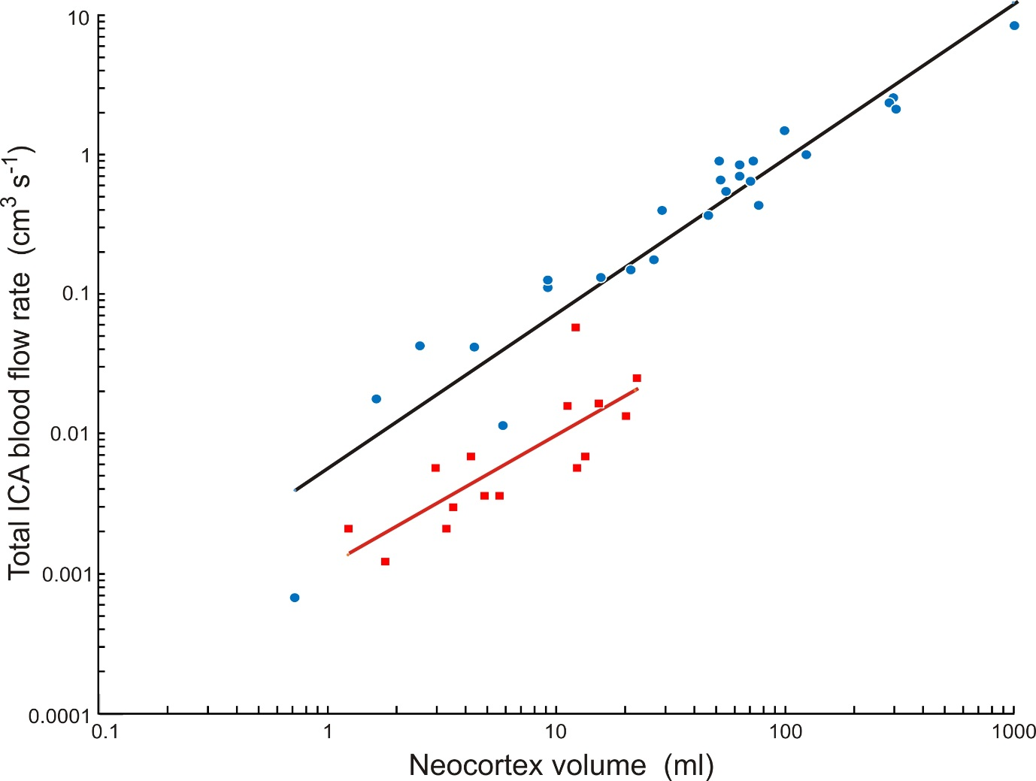

Figure S1. Relationship between total blood flow rate of both ICAs (Q. _{ICA}) and neocortex volume (V_{neo}) in 26 species of haplorhine primates (blue circles) and 15 species of strepsirrhine primates (red squares). Blood flow rates are calculated with the new “empirical equation” and w = 0.30 from foramen radii listed in [5] and [17], and neocortical volumes are from dataset 2 in [34]. The equations are, Q. _{ICA} = 0.0062 V_{neo}^{1.12±0.15 CI} (R² = 0.91) for haplorhines and Q. _{ICA} = 0.0012 V_{neo}^{0.96±0.42 CI} (R² = 0.66) for strepsirrhines. See Table S5 for data.

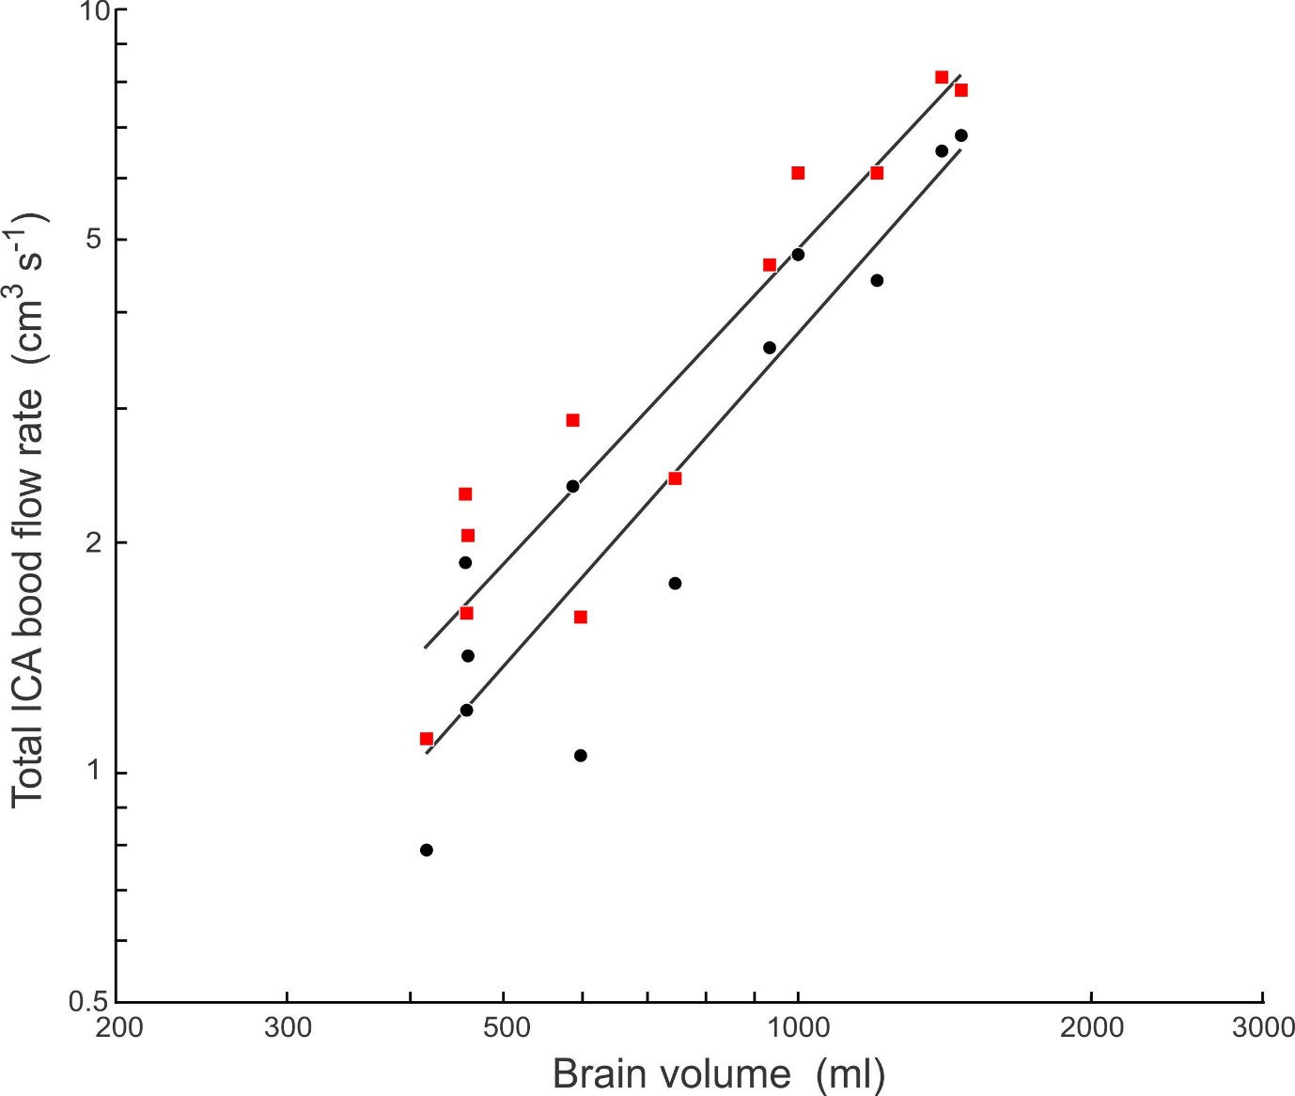

Fig. S2. Comparison of total blood flow rate of both ICAs (Q. _{ICA}) as a function of brain volume (V_{br}) in 11 hominin species (Early and Late H. erectus are given individual points) calculated according to the new “empirical equation” and assuming w = 0.30 (red squares) and calculated from ICA foramen size according to the shear stress equation and assuming w = 0.40 (black circles). The equations are Q. _{ICA} = 0.000373 V_{br}^{1.37} and Q. _{ICA} = 0.000170 V_{br}^{1.45}, respectively. ICA foramen data are from [16] and do not include Ardipithecus ramidus.

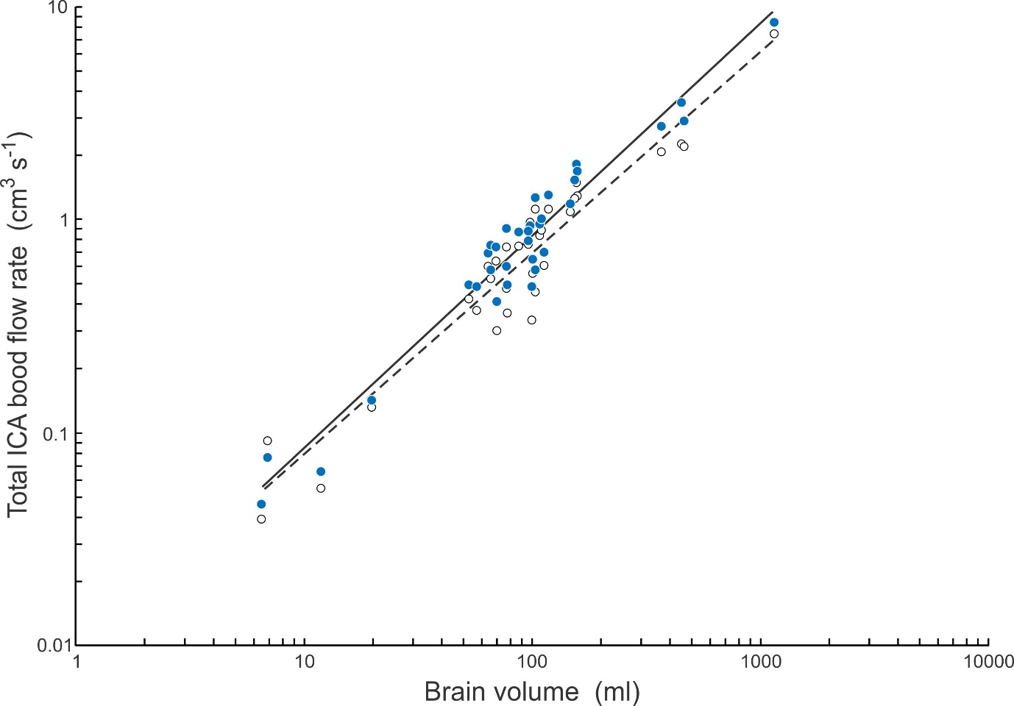
Fig. S3. Comparison of total blood flow rate of both ICAs (Q. _{ICA}) as a function of brain volume (V_{br}) in 34 haplorhine species calculated from ICA foramen size. Results from the “empirical equation” and assuming w = 0.30 (blue circles) are compared to results from the shear stress equation and assuming w = 0.40 (open circles). The equations are Q. _{ICA} = 0.0084 V_{br}^{1.00} and Q. _{ICA} = 0.0088 V_{br}^{0.95}, respectively. ICA foramen data are from [5].

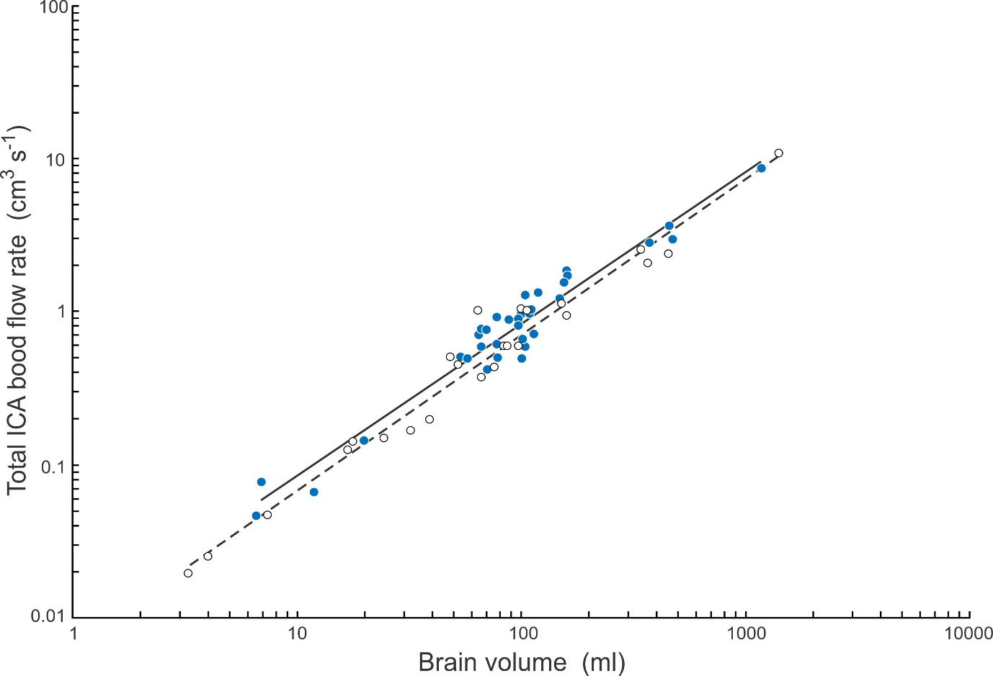

Fig. S4. Total blood flow rate of both ICAs (Q. _{ICA}) as a function of brain volume (V_{br}) in haplorhine primates calculated from ICA foramen radius according to the new “empirical equation” and assuming w = 0.30. Foramen radius data are derived from 34 species from [5] (blue circles) and 24 species from [17] (unfilled circles). The equations are, Q. _{ICA} = 0.0084 V_{br}^{1.00} and Q. _{ICA} = 0.0065 V_{br}^{1.01}, respectively.

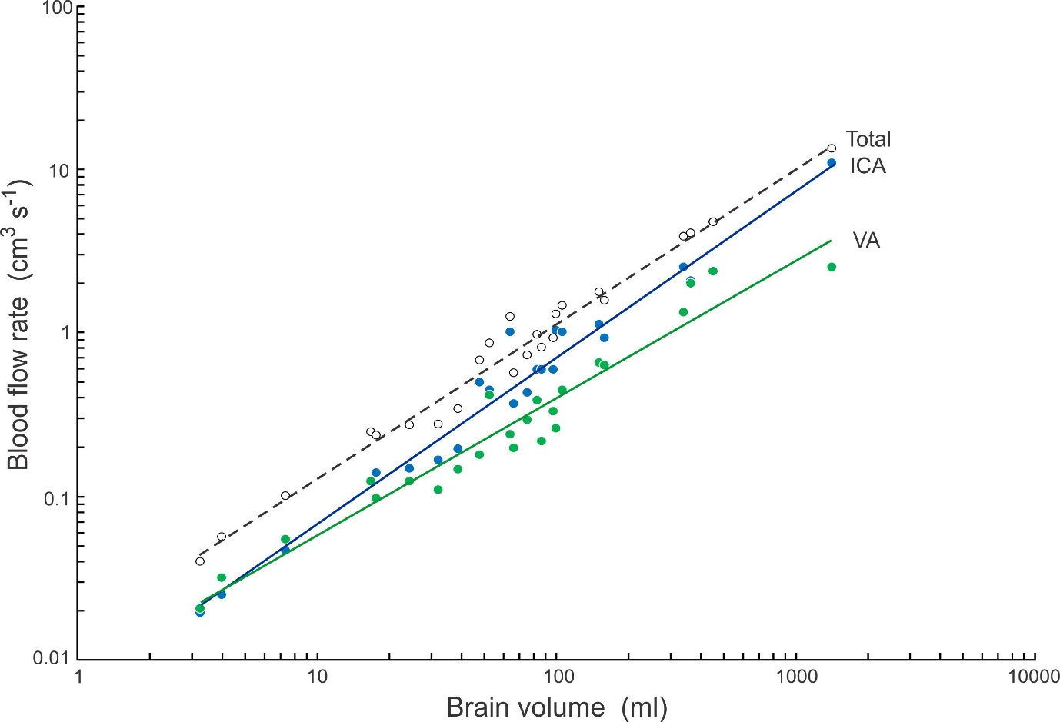
Fig. S5. Blood flow rates of the paired ICAs (Q. _{ICA}), paired vertebral arteries (Q. _{VA}), and the sum of these (Q. _{TOTAL}) plotted as a function of brain volume (V_{br}) in 24 haplorhine species calculated from foramen radius according to the new “empirical equation” and assuming w = 0.30 for the ICA and w = 0.96 for the VA. Data are derived from foramen radius from [17]. The equations are, Q. _{ICA} = 0.0065 V_{br}^{1.01}, Q. _{VA} = 0.0083 V_{br}^{0.84} and Q. _{TOTAL} = 0.0143 V_{br}^{0.95}.

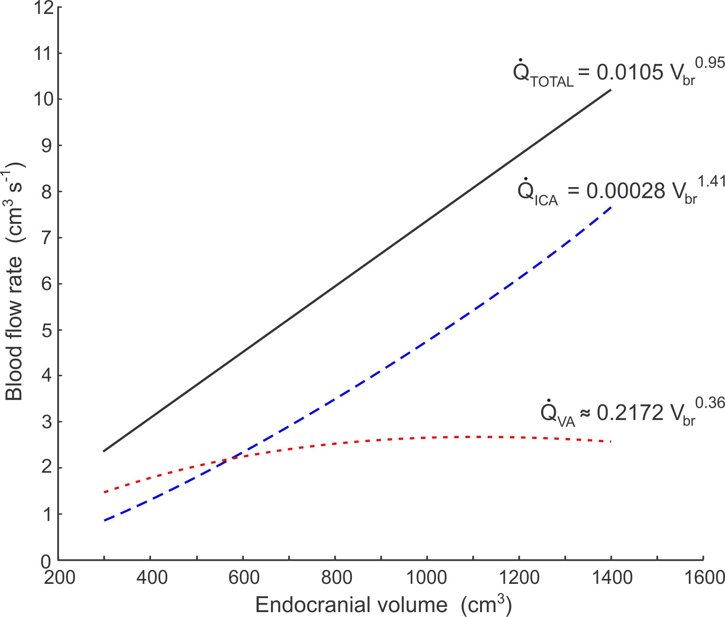
Fig. S6. Model of allometric scaling of hominin brain blood flow rate in relation to brain volume (V_{br}). Power equations describe the lines for total brain blood flow rate (Q. _{TOTAL}), which is the sum of blood flow rate in the internal carotid arteries (Q. _{ICA}) and vertebral arteries (Q. _{VA}). The model procedure is described in the Supplementary material.

Table S1. Literature data for dimensions of the internal carotid artery (ICA), carotid canal (CC) and common carotid artery (CCA) in humans.
Study | Method | Artery/canal | Outer radius (mm) | Lumen radius (mm) | Wall thickness (mm) | Wall-lumen ratio | Notes
Sommer et al. 2010 | In vitro | ICA | 3.17 | 2.56 | 0.61 | 0.24
Watase et al. 2018 | MRI | ICA | 4.30 | 3.40 | 0.90 | 0.26
Saam et al. 2009 | MRI | ICA | 3.98 | 3.33 | 0.64 | 0.19
Cibis et al. 2016 | MRI | ICA | 4.52 | 3.23 | 1.29 | 0.40
Qiao et al. 2016 | MRI | ICA | 4.82 | 3.81 | 1.01 | 0.26
Somesh et al. 2014 | Manual | CC | 3.60 | 2.39 | 1.21 | 0.51 | 1
Calguner et al. 1997 | Manual | CC | 2.79 | 2.39 | 0.40 | 0.17 | 1
Naidoo et al. 2017 | Manual | CC | 3.23 | 2.39 | 0.84 | 0.35 | 1
Berlis et al. 1992 | Manual | CC | 3.38 | 2.39 | 0.99 | 0.41 | 1
Aoun et al. 2013 | Manual | CC | 3.10 | 2.39 | 0.71 | 0.30 | 1
Saba et al. 2013 | MDCTA | CCA | 4.55 | 3.29 | 1.26 | 0.38 | 2
Saba et al. 2008 | MDCTA | CCA | 4.11 | 3.29 | 0.82 | 0.25 | 2
Saba et al. 2010 | MDCTA | CCA | 4.20 | 3.29 | 0.91 | 0.28 | 2
Boussel et al. 2007 | MRI | CCA | 3.91 | 3.24 | 0.67 | 0.21
Methods: In vitro, direct measurements from arteries fixed or observed at mean physiological pressure of 13.3 kPa (= 100 mm Hg). MRI = Magnetic Resonance Imaging. Manual = Direct measurement of bony canal. MDCTA = Multidetector Computed Tomographic Angiography.
Notes: 1, ICA lumen radius taken as the mean from 13 imaging studies [10]. 2, CCA lumen radius taken as the mean from 6 imaging studies [10].
References to be added from below:
[35-48]
Table S2. Summary data for brain volume (V_{br}), internal carotid artery (ICA) foramen radius (r_{o}) and total blood flow rate of both ICAs (Q. _{ICA}) for hominid skulls. Means, 95% CI and sample size (N) are shown.

Species | N | V_{br} | r_{o} | Q. _{ICA}
 |  | (ml) | (cm) | (cm³ s⁻¹)
Gorilla beringei | 16 | 482 ± 30 | 0.223 ± 0.009 | 3.92 ± 0.44
Gorilla gorilla | 13 | 494 ± 40 | 0.208 ± 0.020 | 3.39 ± 0.78
Pongo abelii | 12 | 346 ± 28 | 0.205 ± 0.012 | 3.19 ± 0.49
Pongo pygmaeus | 20 | 357 ± 17 | 0.184 ± 0.010 | 2.44 ± 0.32
Pan troglodytes | 19 | 377 ± 23 | 0.197 ± 0.013 | 2.96 ± 0.47
Pan paniscus | 2 | 300 | 0.178 | 2.20
Homo sapiens | 24 | 1325 ± 79 | 0.271 ± 0.010 | 6.37 ± 0.59
Australopithecus africanus | 8 | 499 ± 56 | 0.156 ± 0.008 | 1.60 ± 0.19
Australopithecus afarensis | 3 | 476 ± 74 | 0.186 ± 0.020 | 2.46 ± 0.64

Table S3. Brain volume (V_{br}) and total blood flow rate of both ICAs (Q. _{ICA}) of haplorhine and hominin primates, calculated according to the “empirical equation” [10] and a wall thickness-to-lumen radius ratio of w = 0.30. Data for endocranial volume and ICA foramen radius are [5, 15] [17], except for Ardipithecus ramidus which came from [49, 50].

 |  | V_{br} | Q. _{ICA}
Species | Taxon | (ml) | (cm³ s⁻¹)
Alouatta sp. | Haplorhini | 53 | 0.445
Aotus trivirgatus | Haplorhini | 17 | 0.123
Ateles geoffroyi | Haplorhini | 107 | 1.007
Cacajao calvus | Haplorhini | 88 | 0.685
Callicebus moloch | Haplorhini | 18 | 0.139
Callithrix jacchus | Haplorhini | 7.0 | 0.046
Callithrix pygmaea | Haplorhini | 5.5 | 0.051
Cebus capucinus | Haplorhini | 67 | 0.367
Cercopithecus mitis | Haplorhini | 71 | 0.413
Cercopithecus neglectus | Haplorhini | 65 | 0.699
Chiropotes satanas | Haplorhini | 48 | 0.496
Chlorocebus aethiops | Haplorhini | 67 | 0.763
Colobus satanas | Haplorhini | 79 | 0.494
Gorilla gorilla | Haplorhini | 458 | 2.970
Homo sapiens | Haplorhini | 1304 | 9.660
Hylobates lar | Haplorhini | 106 | 0.798
Hylobates syndactylus | Haplorhini | 120 | 1.313
Lagothrix lagotricha | Haplorhini | 110 | 0.957
Leontopithecus rosalia | Haplorhini | 12 | 0.065
Lophocebus albigena | Haplorhini | 98 | 0.739
Macaca fascicularis | Haplorhini | 71 | 0.544
Macaca maura | Haplorhini | 105 | 1.272
Macaca mulatta | Haplorhini | 78 | 0.607
Macaca nemestrina | Haplorhini | 112 | 1.014
Macaca nigra | Haplorhini | 150 | 1.196
Macaca ochreata | Haplorhini | 98 | 0.799
Macaca radiata | Haplorhini | 67 | 0.584
Macaca silenus | Haplorhini | 89 | 0.878
Mandrillus leucophaeus | Haplorhini | 160 | 1.376
Mandrillus sphinx | Haplorhini | 161 | 1.696
Miopithecus talapoin | Haplorhini | 39 | 0.194
Nasalis larvatus | Haplorhini | 81 | 0.750
Pan troglodytes | Haplorhini | 409 | 2.713
Papio anubis | Haplorhini | 152 | 1.118
Papio hamadryas | Haplorhini | 157 | 1.538
Piliocolobus badius | Haplorhini | 64 | 1.007
Pithecia pithecia | Haplorhini | 32 | 0.165
Pongo pygmaeus | Haplorhini | 372 | 2.419
Presbytis melalophos | Haplorhini | 71 | 0.747
Saimiri sciureus | Haplorhini | 22 | 0.145
Semnopithecus entellus | Haplorhini | 102 | 0.488
Tarsius sp. | Haplorhini | 3.3 | 0.019
Trachypithecus obscurus | Haplorhini | 105 | 0.584
Trachypithecus vetulus | Haplorhini | 58 | 0.486
Ardipithecus ramidus | Homininae | 315 | 0.843
Australopithecus afarensis | Homininae | 457 | 2.296
Australopithecus africanus | Homininae | 458 | 1.600
Early Homo erectus | Homininae | 939 | 4.588
Late Homo erectus | Homininae | 1004 | 6.043
Homo habilis | Homininae | 590 | 2.870
Homo georgicus | Homininae | 600 | 1.583
Homo heidelbergensis | Homininae | 1213 | 6.043
Homo neanderthalensis | Homininae | 1413 | 8.068
Homo rudolfensis | Homininae | 752 | 2.404
Homo sapiens | Homininae | 1479 | 7.759
Homo naledi | Homininae | 460 | 2.026
Homo floresiensis | Homininae | 417 | 1.094

Table S4. Volumes of brain regions of haplorhine primates from Navarrete et al. (2018) and total blood flow rate of both ICAs (Q. _{ICA}) calculated according to the new “empirical equation” and w = 0.30 from ICA foramen radii in [5] and [17].

Species |  | Telencephalon volume (ml) | Grey matter volume (ml) | Q. _{ICA} (cm³ s⁻¹)
Cercopithecus mitis | Cercopithecidae | 57 | 36 | 0.413
Lophocebus albigena | Cercopithecidae | 78 | 48 | 0.730
Macaca fascicularis | Cercopithecidae | 43 | 27 | 0.542
Macaca mulatta | Cercopithecidae | 73 | 45 | 0.607
Macaca nemestrina | Cercopithecidae | 78 | 43 | 1.014
Macaca nigra | Cercopithecidae | 61 | 34 | 1.196
Macaca silenus | Cercopithecidae | 79 | 51 | 0.878
Mandrillus sphinx | Cercopithecidae | 104 | 67 | 1.696
Papio hamadryas | Cercopithecidae | 140 | 85 | 1.538
Gorilla gorilla | Hominidae | 342 | 174 | 2.932
Pan troglodytes | Hominidae | 287 | 173 | 2.708
Pongo pygmaeus | Hominidae | 263 | 164 | 2.403
Aotus trivirgatus | Platyrrhini | 13 | 10 | 0.123
Callithrix jacchus | Platyrrhini | 6.0 | 4.3 | 0.046
Callithrix pygmaea | Platyrrhini | 3.2 | 2.3 | 0.046
Lagothrix lagotricha | Platyrrhini | 76 | 48 | 0.957
Leontopithecus rosalia | Platyrrhini | 8.7 | 6.4 | 0.065

Table S5. Neocortex volume and total blood flow rate of both ICAs (Q. _{ICA}) of haplorhine and strepsirrhine primates. Neocortex volumes are from dataset 2 in [34]. Blood flow rate data are calculated from ICA foramen radius in [5] and [17].

Species | Taxon | Neocortex volume (ml) | Q. _{ICA} x 2 (cm³ s⁻¹)
Alouatta sp. | Haplorhini | 29 | 0.445
Aotus trivirgatus | Haplorhini | 9.2 | 0.123
Ateles geoffroyi | Haplorhini | 73 | 1.007
Callicebus moloch | Haplorhini | 9.1 | 0.139
Callithrix jacchus | Haplorhini | 4.4 | 0.046
Callithrix pygmaea | Haplorhini | 2.5 | 0.046
Cercopithecus mitis | Haplorhini | 46 | 0.413
Gorilla gorilla | Haplorhini | 298 | 2.932
Homo sapiens | Haplorhini | 1002 | 9.620
Hylobates lar | Haplorhini | 63 | 0.788
Lagothrix lagotricha | Haplorhini | 63 | 0.957
Lophocebus albigena | Haplorhini | 71 | 0.730
Macaca mulatta | Haplorhini | 55 | 0.607
Mandrillus sphinx | Haplorhini | 99 | 1.696
Microcebus murinus | Haplorhini | 0.7 | 0.0007
Miopithecus talapoin | Haplorhini | 27 | 0.194
Nasalis larvatus | Haplorhini | 52 | 0.739
Nycticebus coucang | Haplorhini | 5.8 | 0.012
Pan troglodytes | Haplorhini | 282 | 2.708
Papio anubis | Haplorhini | 122 | 1.118
Piliocolobus badius | Haplorhini | 51 | 1.007
Pithecia pithecia | Haplorhini | 21 | 0.165
Pongo pygmaeus | Haplorhini | 306 | 2.403
Saimiri sciureus | Haplorhini | 16 | 0.145
Semnopithecus entellus | Haplorhini | 76 | 0.488
Tarsius sp. | Haplorhini | 1.6 | 0.019
Avahi laniger | Strepsirrhini | 4.8 | 0.0039
Cheirogaleus major | Strepsirrhini | 2.9 | 0.0061
Cheirogaleus medius | Strepsirrhini | 1.2 | 0.0022
Daubentonia madagascariensis | Strepsirrhini | 22 | 0.028
Eulemur fulvus | Strepsirrhini | 12 | 0.0061
Eulemur mongoz | Strepsirrhini | 12 | 0.063
Galago senegalensis | Strepsirrhini | 1.8 | 0.0013
Indri indri | Strepsirrhini | 20 | 0.015
Lemur catta | Strepsirrhini | 11 | 0.017
Lepilemur sp. | Strepsirrhini | 3.3 | 0.0022
Loris tardigradus | Strepsirrhini | 3.5 | 0.0032
Otolemur crassicaudatus | Strepsirrhini | 4.2 | 0.0075
Perodicticus potto | Strepsirrhini | 5.6 | 0.0039
Propithecus verreauxi | Strepsirrhini | 13 | 0.0075
Varecia sp. | Strepsirrhini | 15 | 0.018

References
1. Burton A.C. 1965 Physiology and Biophysics of the Circulation. Chicago, Year Book Medical Publishers Incorporated; 217 p.
2. Caro C.G., Pedley T.J., Schroter R.C., Seed W.A. 2012 The Mechanics of the Circulation. Cambridge, Cambridge University Press.
3. White C.R., Seymour R.S. 2014 The role of gravity in the evolution of mammalian blood pressure. Evolution 68, 901-908. (doi:10.1111/evo.12298).
4. Wolinsky H., Glagov S. 1967 A lamellar unit of aortic medial structure and function in mammals. Circulation Research 20, 99-111.
5. Seymour R.S., Angove S.E., Snelling E.P., Cassey P. 2015 Scaling of cerebral blood perfusion in primates and marsupials. Journal of Experimental Biology 218, 2631-2640. (doi:10.1242/jeb.124826).
6. Orsi A.M., Domeniconi R.F., Artoni S.M.B., Filho J.G. 2006 Carotid arteries in the dog: Structure and histophysiology. International Journal of Morphology 24, 239-244.
7. Skilton M.R., Boussel L., Bonnet F., Bernard S., Douek P.C., Moulin P., Serusclat A. 2011 Carotid intima-media and adventitial thickening: Comparison of new and established ultrasound and magnetic resonance imaging techniques. Atherosclerosis 215, 405-410. (doi:10.1016/j.atherosclerosis.2010.12.036).
8. Gules I., Satoh M., Clower B.R., Nanda A., Zhang J.H. 2002 Comparison of three rat models of cerebral vasospasm. American Journal of Physiology-Heart and Circulatory Physiology 283, H2551-H2559. (doi:10.1152/ajpheart.00616.2002).
9. Lehoux S., Tedgui A. 2003 Cellular mechanics and gene expression in blood vessels. Journal of Biomechanics 36, 631-643. (doi:10.1016/S0021-9290(02)00441-4).
10. Seymour R.S., Hu Q., Snelling E.P., White C.R. 2019 Interspecific scaling of blood flow rates and arterial sizes in mammals. Journal of Experimental Biology 222, jeb 199554. (doi:10.1242/jeb.199554).
11. Greve J.M., Les A.S., Tang B.T., Blomme M.T.D., Wilson N.M., Dalman R.L., Pelc N.J., Taylor C.A. 2006 Allometric scaling of wall shear stress from mice to humans: quantification using cine phase-contrast MRI and computational fluid dynamics. American Journal of Physiology Heart and Circulatory Physiology 291, H1700-H1708. (doi:10.1152/ajpheart.00274.2006).
12. Cheng C., Helderman F., Tempel D., Segers D., Hierck B., Poelmann R., van Tol A., Duncker D.J., Robbers-Visser D., Ursem N.T.C., et al. 2007 Large variations in absolute wall shear stress levels within one species and between species. Atherosclerosis 195, 225-235. (doi:10.1016/j.atherosclerosis.2006.11.019).
13. Weinberg P.D., Ethier C.R. 2007 Twenty-fold difference in hemodynamic wall shear stress between murine and human aortas. Journal of Biomechanics 40, 1594-1598. (doi:10.1016/j.jbiomech.2006.07.020).
14. Seymour R.S., Snelling E.P. 2019 Calculating brain perfusion of primates. Journal of Human Evolution 128, 99-102. (doi:10.1016/j.jhevol.2018.06.001).
15. Seymour R.S., Bosiocic V., Snelling E.P. 2016 Fossil skulls reveal that blood flow rate to the brain increased faster than brain volume during human evolution. Royal Society Open Science 3, 160305. (doi:10.1098/rsos.160305).
16. Seymour R.S., Bosiocic V., Snelling E.P. 2017 Correction to 'Fossil skulls reveal that blood flow rate to the brain increased faster than brain volume during human evolution'. Royal Society Open Science 4, 170846. (doi:10.1098/rsos.170846).
17. Boyer D.M., Harrington A.R. 2019 New estimates of blood flow rates in the vertebral artery of euarchontans and their implications for encephalic blood flow scaling: A response to Seymour and Snelling (2018). Journal of Human Evolution 128, 93-98. (doi:10.1016/j.jhevol.2018.10.002).
18. Boyer D.M., Harrington A.R. 2018 Scaling of bony canals for encephalic vessels in euarchontans: Implications for the role of the vertebral artery and brain metabolism. Journal of Human Evolution 114, 85-101. (doi:10.1016/j.jhevol.2017.09.003).
19. White C.R., Blackburn T.M., Seymour R.S. 2009 Phylogenetically informed analysis of the allometry of mammalian basal metabolic rate supports neither geometric nor quarter-power scaling. Evolution 63, 2658-2667. (doi:10.1111/j.1558-5646.2009.00747.x).
20. Calder W.A., III. 1996 Size, Function, and Life History. 2 ed. Mineola, New York, Dover Publications; 431 p.
21. Holt J.P., Rhode E.A., Holt W.W., Kines H. 1981 Geometric similarity of aorta, venae cavae, and certain of their branches in mammals. American Journal of Physiology Regulatory, Integrative and Comparative Physiology 241, 100-104.
22. Batson O.V. 1944 Anatomical problems concerned in the study of cerebral blood flow. Federation Proceedings 3, 139-144.
23. Yousry I., Forderreuther S., Moriggl B., Holtmannspotter M., Naidich T.P., Straube A., Yousry T.A. 2001 Cervical MR imaging in postural headache: MR signs and pathophysiological implications. American Journal of Neuroradiology 22, 1239-1250.
24. Zhao X.X., Zhao M.D., Amin-Hanjani S., Du X.J., Ruland S., Charbel F.T. 2015 Wall shear stress in major cerebral arteries as a function of age and gender--a study of 301 healthy volunteers. Journal of Neuroimaging 25, 403-407. (doi:10.1111/jon.12133).
25. Schöning M., Walter J., Scheel P. 1994 Estimation of cerebral blood flow through color duplex sonography of the carotid and vertebral arteries in healthy adults. Stroke 25, 17-22.
26. Scheel P., Ruge C., Schöning M. 2000 Flow velocity and flow volume measurements in the extracranial carotid and vertebral arteries in healthy adults: reference data and the effects of age. Ultrasound in Medicine and Biology 26, 1261-1266.
27. Ford M.D., Alperin N., Lee S.H., Holdsworth D.W., Steinman D.A. 2005 Characterization of volumetric flow rate waveforms in the normal internal carotid and vertebral arteries. Physiological Measurement 26, 477-488. (doi:10.1088/0967-3334/26/4/013).
28. Sato K., Sadamoto T. 2010 Different blood flow responses to dynamic exercise between internal carotid and vertebral arteries in women. Journal of Applied Physiology 109, 864-869. (doi:10.1152/japplphysiol.01359.2009).
29. Wåhlin A., Ambarki K., Hauksson J., Birgander R., Malm J., Eklund A. 2012 Phase contrast MRI quantification of pulsatile volumes of brain arteries, veins, and cerebrospinal fluids compartments: Repeatability and physiological interactions. Journal of Magnetic Resonance Imaging 35, 1055-1062. (doi:10.1002/jmri.23527).
30. Kim C., Lee S.H., Park S.S., Kim B.J., Ryu W.S., Kim C.K., Oh M.Y., Chung J.W., Yoon B.W. 2012 A quantitative comparison of the vertebral artery and transverse foramen using CT angiography. Journal of Clinical Neurology 8, 259-264. (doi:10.3988/jcn.2012.8.4.259).
31. Epstein H.M., Linde H.W., Crampton A.R., Ciric I.S., Eckenhoff J.E. 1970 The vertebral venous plexus as a major cerebral venous outflow tract. Anesthesiology 32, 332-337.
32. Eckenhoff J.E. 1971 The vertebral venous plexus. Canadian Anaesthetists Society Journal 18, 487-495.
33. Diedrichsen J., King M., Hernandez-Castillo C., Sereno M., Ivry R.B. 2019 Universal transform or multiple functionality? Understanding the contribution of the human cerebellum across task domains. Neuron 102, 918-928. (doi:10.1016/j.neuron.2019.04.021).
34. Miller I.F., Barton R.A., Nunn C.L. 2019 Quantitative uniqueness of human brain evolution revealed through phylogenetic comparative analysis. Elife 8, e41250. (doi:10.7554/eLife.41250.001).
35. Sommer G., Regitnig P., Költringer L., Holzapfel G.A. 2010 Biaxial mechanical properties of intact and layer-dissected human carotid arteries at physiological and supraphysiological loadings. American Journal of Physiology (Heart and Circulatory Physiology) 298, H898-H912. (doi:10.1152/ajpheart.00378.2009).
36. Watase H., Sun J., Hippe D.S., Balu N., Li F.Y., Zhao X.H., Mani V., Fayad Z.A., Fuster V., Hatsukami T.S., et al. 2018 Carotid artery remodeling is segment specific: An in vivo study by vessel wall magnetic resonance imaging. Arteriosclerosis Thrombosis and Vascular Biology 38, 927-934. (doi:10.1161/atvbaha.117.310296).
37. Saam T., Raya J.G., Cyran C.C., Bochmann K., Meimarakis G., Dietrich O., Clevert D.A., Frey U., Yuan C., Hatsukami T.S., et al. 2009 High resolution carotid black-blood 3T MR with parallel imaging and dedicated 4-channel surface coils. Journal of Cardiovascular Magnetic Resonance 11. (doi:10.1186/1532-429x-11-41).
38. Cibis M., Potters W.V., Selwaness M., Gijsen F.J., Franco O.H., Lorza A.M.A., de Bruijne M., Hofman A., van der Lugt A., Nederveen A.J., et al. 2016 Relation between wall shear stress and carotid artery wall thickening MRI versus CFD. Journal of Biomechanics 49, 735-741. (doi:10.1016/j.jbiomech.2016.02.004).
39. Qiao Y., Guallar E., Suri F.K., Liu L., Zhang Y.Y., Anwar Z., Mirbagheri S., Xie Y.J., Nezami N., Intrapiromkul J., et al. 2016 MR imaging measures of intracranial atherosclerosis in a population-based study. Radiology 280, 860-868. (doi:10.1148/radiol.2016151124).
40. Somesh M.S., Sridevi H.B., Murlimanju B.V., Pai S.R. 2014 Morphological and morphometric study of carotid canal in Indian population. International Journal of Biomedical Research 5, 455-460. (doi:10.7439/ijbr).
41. Çalgüner E., Turgut H.B., Gözil R., Tunc E., Sevim A., Keskil S. 1997 Measurements of the carotid canal in skulls from Anatolia. Acta Anatomica 158, 130-132.
42. Naidoo N., Lazarus L., Ajayi N.O., Satyapal K.S. 2017 An anatomical investigation of the carotid canal. Folia Morphologica 76, 289-294. (doi:10.5603/FM.a2016.0060).
43. Berlis A., Putz R., Schumacher M. 1992 Direct and CT measurements of canals and foramina of the skull base. The British Journal of Radiology 65, 653-661.
44. Aoun M.A., Nasr A.Y., Aziz A.M.A. 2013 Morphometric study of the carotid canal. Life Science Journal 10, 2559-2562.
45. Saba L., Sanfilippo R., Montisci R., Suri J.S., Mallarini G. 2013 Carotid artery wall thickness measured using CT: Inter- and intraobserver agreement analysis. American Journal of Neuroradiology 34, E13-E18. (doi:10.3174/ajnr.A2796).
46. Saba L., Sanfilippo R., Pascalis L., Montisci R., Caddeo G., Mallarini G. 2008 Carotid artery wall thickness and ischemic symptoms: evaluation using multi-detector-row CT angiography. European Radiology 18, 1962-1971. (doi:10.1007/s00330-008-0962-5).
47. Saba L., Sanfilippo R., Montisci R., Mallarini G. 2010 Carotid artery wall thickness: comparison between sonography and multi-detector row CT angiography. Neuroradiology 52, 75-82. (doi:10.1007/s00234-009-0589-5).
48. Boussel L., Serusclat A., Skilton M.R., Vincent F., Bernard S., Moulin P., Saloner D., Douek P.D. 2007 The reliability of high resolution MRI in the measurement of early stage carotid wall thickening. Journal of Cardiovascular Magnetic Resonance 9, 771-776.
49. Suwa G., Asfaw B., Kono R.T., Kubo D., Lovejoy C.O., White T.D. 2009 The Ardipithecus ramidus skull and its implications for hominid origins. Science 326, 68-68e67. (doi:10.1126/science.1175825).
50. Kimbel W.H., Suwa G., Asfaw B., Rak Y., White T.D. 2014 Ardipithecus ramidus and the evolution of the human cranial base. Proceedings of the National Academy of Sciences of the United States of America 111, 948-953. (doi:10.1073/pnas.1322639111).

